**Spring boot testing**

**Whenever we create spring boot project with spring initializer**

**By default spring boot testing dependencies added.**

**Spring boot internally use jUnit 5.x version testing.**

**Starter for testing Spring Boot applications with libraries including JUnit Jupiter, Hamcrest and Mockito**

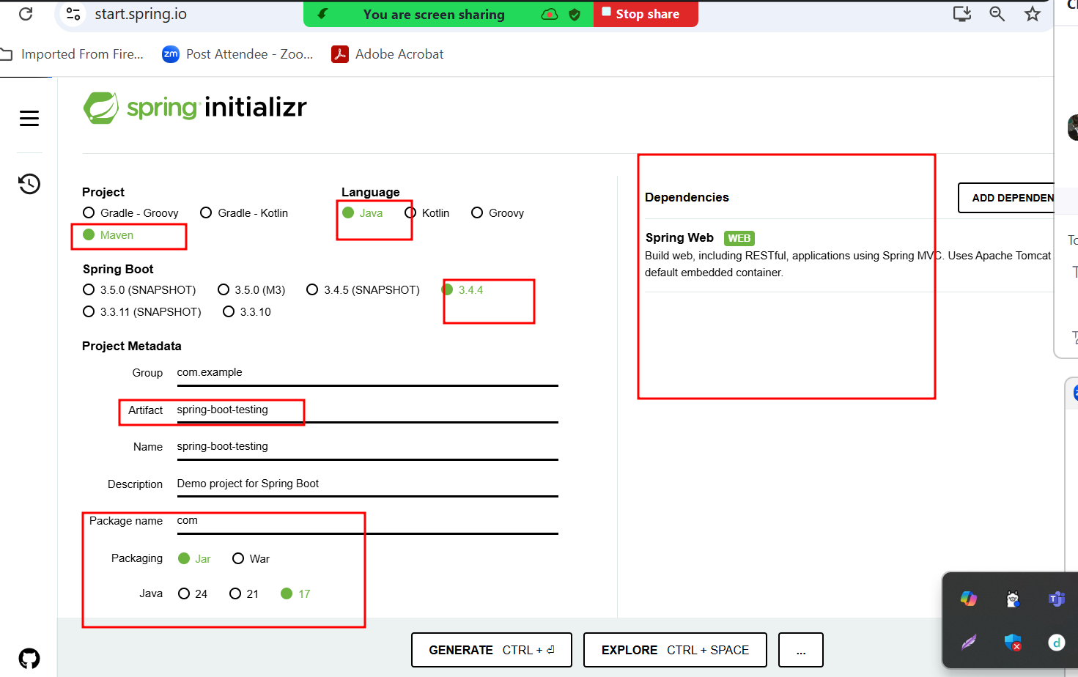

**Spring boot test provided new annotation ie**

**@SpringBootTest: this annotation is use to run spring boot testing programs. This annotation on class level annotation.**

**Dao layer**

**Service layer**

**Controller or RestController**

**If we develop application using jdbc or jdbcTemplate or JPA then we need to write test case. But if we use Spring JPA Data no need to write any test case.**

**In spring boot we need to write test case for service and controller layer. Controller can be normal controller (view as thymeleaf) or restcontroller.**

**Steps to create execute jar file for spring boot projects.**

**Using maven ie mvc command**

**We need to open the terminal inside a project directory in place where pom.xml present.**

**Run the command as**

**mvn package (this command is use to care jar or war)**

**we can create jar or war file using eclipse also.**

**Right click on your project and select the option as run 🡪 maven install.**

**Initially it will download few dependencies and inside a target you can see .jar file**